**A self-driving microscopy system for intelligent in vitro imaging of oocyte maturation**

*Abstract*—Continuous time-lapse imaging is essential for assessing the developmental competence and viability of oocytes during in vitro maturation. However, most commercial systems require individual oocytes to be cultured in specialized microwells, a configuration that can limit optimal developmental conditions. This study presents an intelligent culture and time-lapse imaging system compatible with standard manual culture dishes. The platform integrates a precision-controlled three-axis microscope and a deep learning-based computer vision pipeline, thus preserving high-quality imaging throughout extended recording periods. The vision framework accurately localizes and tracks porcine cumulus–oocyte complexes (COCs) despite subtle positional drift and automatically quantifies cumulus expansion as an early morphological indicator of maturation. Long-term time-lapse experiments validated the system, demonstrating detection accuracies greater than 99% and complete recovery of oocytes within culture wells. Furthermore, the time-lapse system also functions effectively with embryos following oocyte maturation, which distinguishes it from current commercial time-lapse systems. The modular design and open-source software architecture enable convenient customization for diverse applications, offering a scalable and cost-effective solution for automated time-lapse microscopy.

*Keywords*—Self-driving microscope; Automated time lapse imaging; Real-time autofocus; Machine learning;

# **INTRODUCTION**

Continuous observation of oocyte maturation in vitro is essential for elucidating morphokinetic markers that determine developmental competence and viability [1], [2]. Conventional endpoint imaging methods are inadequate for capturing rapid morphological transitions, such as germinal vesicle breakdown, polar body extrusion, or cumulus expansion, often leading to incomplete or biased assessments [3], [4]. Time-lapse microscopy overcomes these limitations by providing uninterrupted, real-time imaging. Moreover, the integration of motorized positioning, autofocus algorithms, and environmental control has significantly improved accuracy and reproducibility while reducing human-induced variability [5]. Recent advancements in automated microscopy platforms, especially those incorporating motorized stages and advanced autofocus systems, have markedly improved the accuracy, reliability, and reproducibility of long-term cellular imaging [6], [7], [8], [9]. By minimizing the need for manual intervention, these systems help reduce experimental variability and limit potential inconsistencies in the collected data [10], [11], [12], [13].

Commercial time-lapse microscopy systems have become increasingly prominent in vitro maturation (IVM) workflows [14], [15]. Unlike traditional cohort-based culture, individual monitoring of oocytes enables objective and granular data collection, forming the basis for predictive assessment of maturation success and embryonic development potential [16], [17], [18], [19]. However, a major technical challenge persists: the spatial displacement of the COC during maturation. Cumulus expansion often causes drifting, resulting in objects moving outside the microscope’s field of view and interrupting continuous tracking [20], [21], [22]. To address this, specialized micro-well culture dishes have been developed, physically constraining each COC and enabling stable image acquisition [23], [24]. These designs are optimized for single-oocyte culture and allow high-throughput tracking of up to 96 oocytes in parallel [25].

Nevertheless, micro-well environments raise biological concerns. Studies indicate that confining oocytes or embryos in small-volume spaces may impair development due to the accumulation of metabolic byproducts, such as ammonia, which can lead to oxidative stress and reduced cellular potential [26], [27], [28], [29], [30]. Although standard culture dishes with larger volumes mitigate this issue [31], they pose a significant challenge for commercial systems in maintaining object tracking and focus continuity. Resolving this trade-off has driven recent research in automated microscopy. Artificial intelligence (AI) and computer vision have become central to these efforts [32], [33], [34], [35]. Machine learning techniques have been increasingly developed to support automated object localization and focus optimization in microscopy[36], [37], [38], [39]. These approaches enable accurate detection across wide imaging fields and have demonstrated superior performance compared to traditional methods, particularly in enhancing focus accuracy, reducing exposure duration, and minimizing phototoxic effects during live-cell imaging [40], [41], [42]. Despite these advancements, no fully integrated system has yet been demonstrated to reliably perform time-lapse imaging on standard culture dishes without requiring hardware modifications. The challenge of seamlessly tracking free-moving objects while maintaining stable focus remains a critical barrier.

To address these limitations, this study introduces an intelligent time-lapse imaging system designed for compatibility with standard culture dishes and housed within a custom-built incubation chamber. The system integrates a precision-controlled three-axis microscope with a deep learning-enabled computer vision platform. Object detection and Tenengrad-based autofocus operate concurrently, ensuring consistent localization and focus despite minor positional drift. Once detected, a specialized segmentation model continuously delineates the cumulus boundary, enabling automated quantification of expansion over time—a key morphokinetic indicator of oocyte maturation. System performance was validated through long-term time-lapse experiments on porcine oocytes, demonstrating stable culture support and accurate image acquisition. The deep learning models trained on more than 4900 labeled images achieved over 99% detection accuracy, with a 100% retrieval rate of oocytes within wells. Following maturation in the system, oocytes were denuded (cumulus cells removed), and the subsequent embryos were successfully cultured and monitored via time-lapse in the same system. Crucially, its modular design and open-source architecture enable adaptation for various applications beyond reproductive biology, including stem cell research, cancer studies, and drug testing. This study presents a scalable and cost-effective platform that enhances the capabilities of automated time-lapse microscopy for broader biomedical research applications.

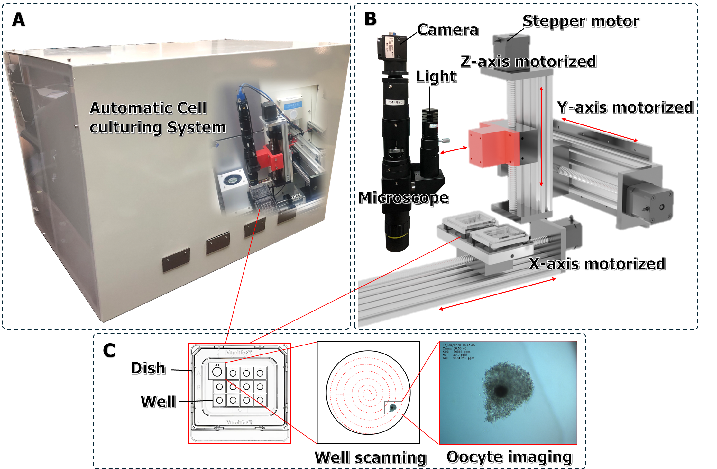

**Fig. 1** Automated cell culturing and monitoring system integrated with a 3-DOF motorized microscope camera: (A) The automated cell culturing chamber with integrated environmental control, (B) Mechanical structure comprising a coaxial light source, microscope camera module, and motorized X–Y–Z stage driven by stepper motors, (C) Culture dish used for oocyte culture, illustrating the well-scanning process for cell localization and imaging.

# **METHODS AND MATERIALS**

## **Automation systems**

This study proposed an automated COC culturing and monitoring system (**Fig. 1**), which integrates a three-degree-of-freedom (3-DOF) motorized microscope platform with an enclosed culture chamber. This design facilitates continuous observation and time-lapse imaging of live COC morphology within a controlled and stable environment. The culturing chamber (**Fig. 1(A)**) is a sealed unit integrated with an environmental control system to maintain optimal physiological conditions required for cellular development. Parameters such as temperature, humidity, and gas concentrations (CO₂ and O₂) are precisely regulated, directly influencing cell growth and viability, particularly during oocyte maturation. The chamber maintains a stable internal temperature of 38.5°C, which reflects the physiological body temperature of the pigs used as the experimental model. The CO₂ concentration is maintained at 5% to stabilize the medium pH, while oxygen is kept at 5-7% to minimize oxidative stress, support mitochondrial function, and enhance ATP production. The system adjusts to environmental fluctuations and achieves stability within 30 seconds, minimizing disruption to the culture process and providing continuous monitoring over time.

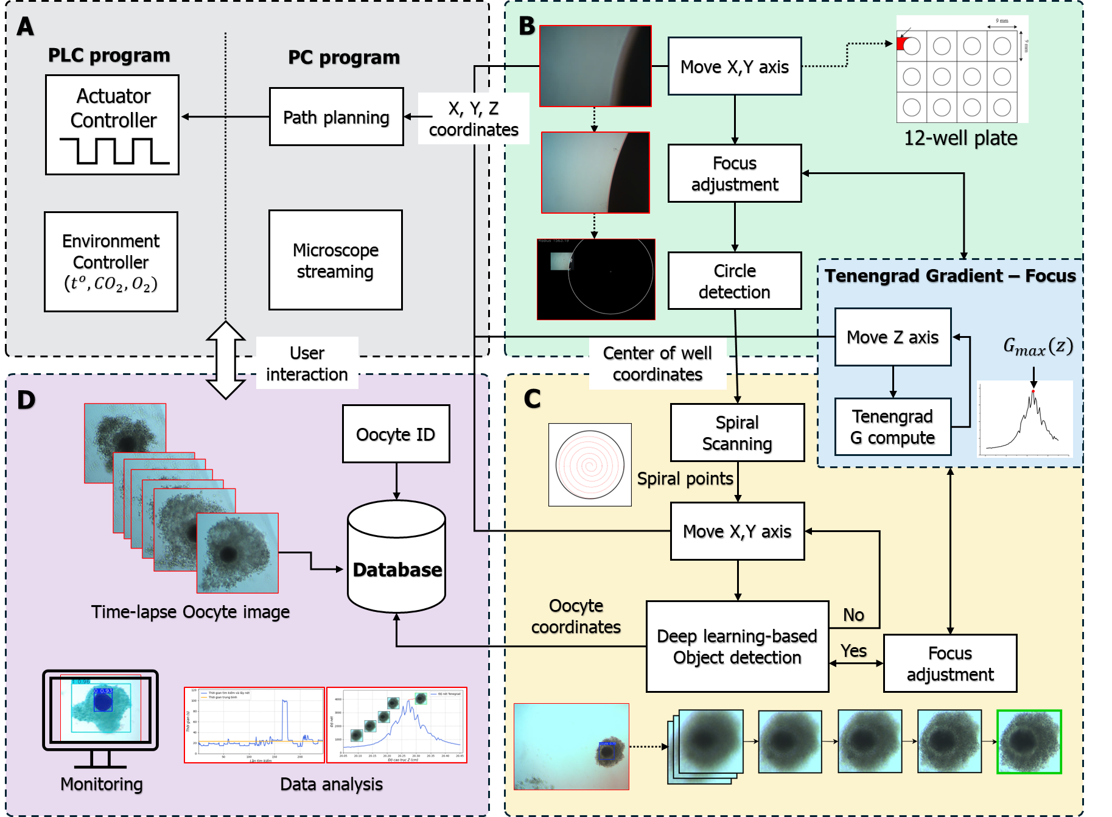

**Fig. 2** Workflow of the automated oocyte time-lapse imaging and monitoring system: (A) System integrating Programmable Logic Controller (PLC)-based actuator and environmental controllers with path planning and microscope streaming; (B) Well detection and centering using X–Y stage control and focus adjustment via Tenengrad gradient method; (C) Oocyte localization using spiral scanning with deep learning-based object detection and Z-axis autofocus; (D) Time-lapse image acquisition, oocyte identification, database storage, and downstream monitoring and analysis.

The microscope camera module is mounted on two linear translation stages along the Y and Z axes while the culture dish is positioned on an additional translation stage along the X axis (**Fig. 1(B)**). All three axes are driven by stepper motors with a mechanical resolution of 0.3125 μm per microstep, forming a 3-DOF motion platform that enables automated scanning and precise positioning across the entire culture dish. This ensures high accuracy for positioning and focusing at microscopic scales. The optical system incorporates a microscope camera module integrated with coaxial illumination and a high-resolution 5.0-megapixel color camera (CS500-C; Shodensha; Japan). The microscope lens (SDS-NSH-Kx10; Shodensa; Japan) provides a standard magnification of 150X suitable for the dimensions of oocytes during time-lapse imaging. The flexible optical assembly enables continuous image acquisition suitable for real-time observation and extended time-lapse sequences throughout cell culture. In this study, a standard manual culture dish (Culture Dish 353651; Vitrolife; Sweden) was used to evaluate the automated time-lapse imaging capability of the developed system (**Fig. 1(C)**). This culture dish contains 12 wells, each approximately 1.75 mm in diameter and 2 mm deep. Porcine oocytes with an average diameter ranging from 115 to 125 μm, including the zona pellucida, were selected as biological samples for time-lapse imaging. Using these oocytes with the chosen culture dish required the development of an optimized workflow for automated cell localization and state tracking.

## **Time-lapse workflow**

The control and processing of the automated cell culturing and monitoring system (**Fig. 2**) requires the integration of several key components: a motion controller for the 3-DOF positioning platform, an environmental control module for maintaining stable microclimate conditions, computer vision algorithms, machine learning models, and a user interaction interface. The microscope camera functions as an active end-effector, receiving continuous feedback from the vision system. It dynamically adjusts its position along the X and Y axes to target specific coordinates within the culture wells, and along the Z axis to achieve precise autofocus. This closed-loop control architecture ensures real-time responsiveness and accuracy in cell localization and imaging.

### **Autofocus using Tenengrad Gradient**

This study used manually operated culture dishes in the time-lapse system, which may introduce mechanical tolerances that result in positional deviations during the imaging process. Additionally, variations in buffer solution volume and gas exchange over extended culture periods may alter the vertical positioning of cells within the culture wells, thereby causing fluctuations in the focal plane. Such fluctuations directly affect the relative positioning between the wells, the cells, and the moving microscope camera, potentially degrading image quality over time. Consequently, precise autofocus is crucial in automated microscopy systems, especially for long-term time-lapse imaging experiments, as even minor shifts in focus can significantly impact image clarity and data reliability. Several autofocus methods have been developed for microscopic imaging, including variance-based, Laplacian-based, and frequency-domain techniques. Among these methods, the Tenengrad gradient-based technique is particularly favored due to its superior performance in terms of computational speed and accuracy, without requiring extensive training datasets or complex pre-processing steps. In this study, the Tenengrad gradient method (**Fig. 2** **(B) & (C)**) was employed due to its computational efficiency, robustness against noise, and its effectiveness for both grayscale and low-contrast biological images typically encountered in cell imaging applications.

The Tenengrad focus measure calculates the sum of squared gradient magnitudes derived from a Sobel operator. For a grayscale image $I\left(x,y\right)$, the focus score $G$ is computed as:

|  |  |
| --- | --- |
| $$G=\sum_{x,y}{\left[G_{x}{\left(x,y\right)}^{2}+G_{y}{\left(x,y\right)}^{2}\right]}$$ | (1) |

Where $G_{x}\left(x,y\right)$ and $G_{y}\left(x,y\right)$ are horizontal and vertical gradients obtained via Sobel kernels. To reduce noise interference, a threshold $T$ may be applied such that:

|  |  |
| --- | --- |
| $$G=\sum_{x,y}{\left[\left(G_{x}^{2}+G_{y}^{2}\right)⋅I\left(\sqrt{G_{x}^{2}+G_{y}^{2}}>T\right)\right]}$$ | (2) |

The indicator function $I\left(∙\right)$ returns 1 if the condition is satisfied and 0 otherwise, effectively filtering out low-gradient regions that are unlikely to contribute meaningful edge information. To ensure optimal autofocus performance, the system must accurately identify the focal plane corresponding to the bottom of the culture well or the position of the oocyte within the buffer solution. In microfluidic culture environments, the vertical position of the observation plane may vary depending on the buffer volume and the geometric characteristics of the culture dish. The scan range $\left[z_{min},z_{max}\right]$ is defined based on the typical well depth (~2 mm) and the volume of buffer solution used (~80–100 μL per well), which generally forms a fluid layer with a height of approximately 1.5–2.5 mm. The optimal focal plane $z^{*}$ is determined by computing the Tenengrad sharpness score $G\left(z_{i}\right)$ at each discrete Z-axis position $z_{i}$:

|  |  |
| --- | --- |
| $$z^{*}=\arg{\max_{z_{i}∈\left[z_{min},z_{max}\right]}{G}}\left(z_{i}\right)$$ | (3) |

### **Well detection and scanning method**

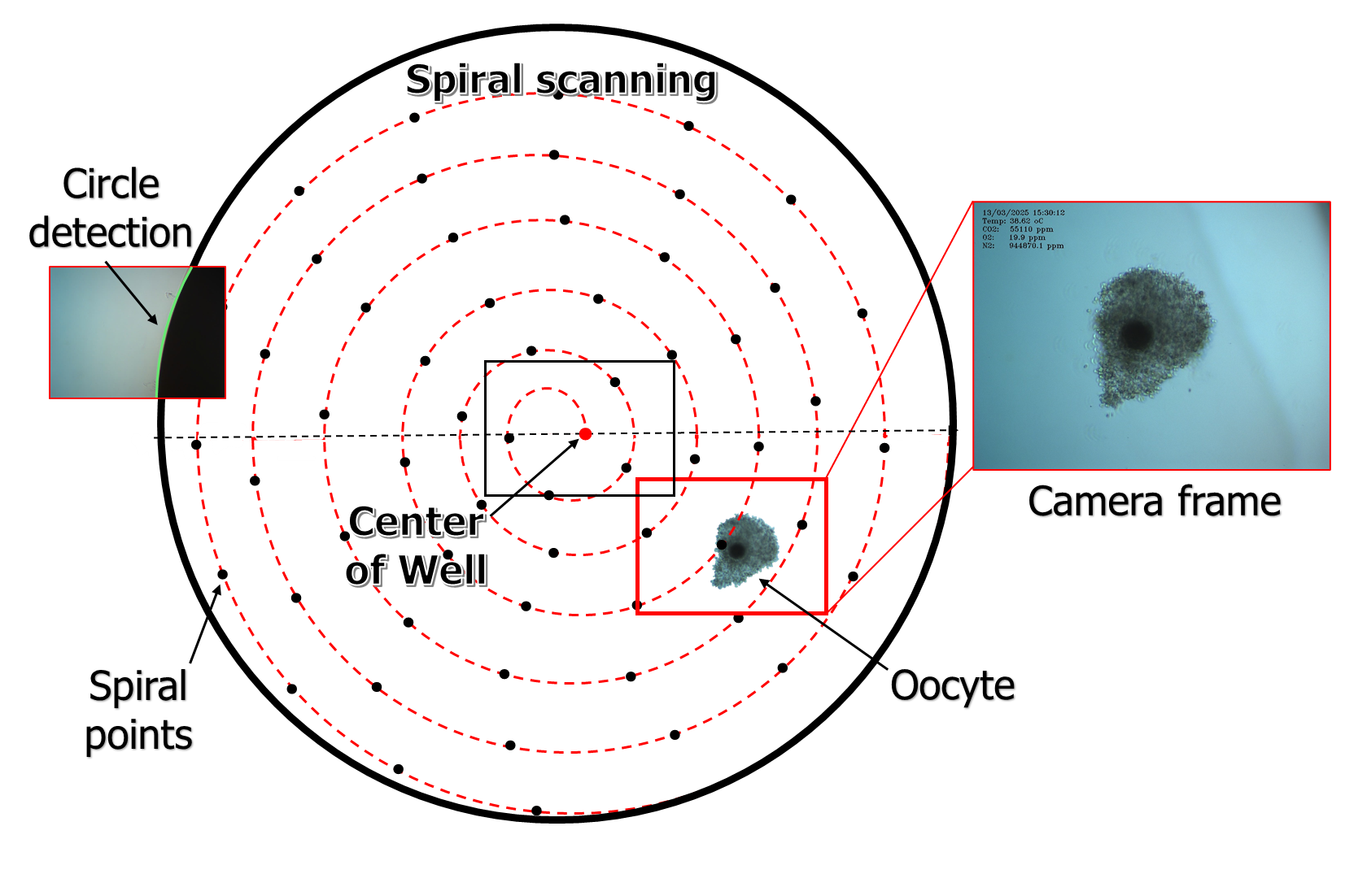

**Fig. 3** Oocyte localization and detection process in a culture well using spiral scanning.

The procedure for detecting and localizing oocytes within each culture well begins by positioning the microscope camera at a predetermined location on the edge of the well (**Fig. 2(B)**). Once positioned, autofocus adjustment is performed using feedback from the Tenengrad gradient method (Eq. 3) to determine the optimal focal plane. After acquiring an image at this focal position, the Canny edge detection algorithm is applied to highlight the well boundaries. The resulting edge points from the Canny filter serve as input to the Circular Hough Transform, which identifies sets of points fitting the circle equation, thereby accurately determining the center coordinates of the well based on the general circle equation:

|  |  |
| --- | --- |
| $${\left(x-x_{c}\right)}^{2}+{\left(y-y_{c}\right)}^{2}={r_{w}}^{2}$$ | (4) |

where $\left(x_{c},y_{c}\right)$ represents the center coordinates, and $r_{w}$ is the radius of the detected well boundary.

Following the identification of the well center, scanning of the oocytes within the well is initiated. Various scanning strategies have been employed to explore the search space within culture wells systematically. Common methods include rectangular raster scanning, zigzag scanning, logarithmic spiral scanning, and concentric circular scanning. However, each of these techniques presents specific limitations in terms of total travel distance, redundancy due to overlapping scan regions, or inefficiencies in covering the circular geometry of typical culture wells. In this study, the Archimedean spiral trajectory was selected for its distinct advantages, including smooth continuous motion, uniform area coverage, and optimized scanning time (**Fig. 3**). This trajectory allows the system to begin scanning from the well center, where the probability of oocyte presence is highest, and expands outward in evenly spaced loops. The spiral path ensures that no regions within the well are missed while simultaneously minimizing the total travel distance between scanning points. This approach improves both mechanical efficiency and spatial resolution, making it particularly well-suited for long-term, high-frequency time-lapse acquisition. The following equation mathematically defines the Archimedean spiral trajectory:

|  |  |
| --- | --- |
| $$r\left(θ\right)=a+b∙\left(θ\right)$$ | (5) |

where r is the radial distance from the center, $θ$ is the angular coordinate, a is the initial offset (typically set to zero, meaning the spiral begins at the well center), and b is a constant defining the distance between successive loops of the spiral.

The corresponding Cartesian coordinates for the scanning trajectory are calculated as follows:

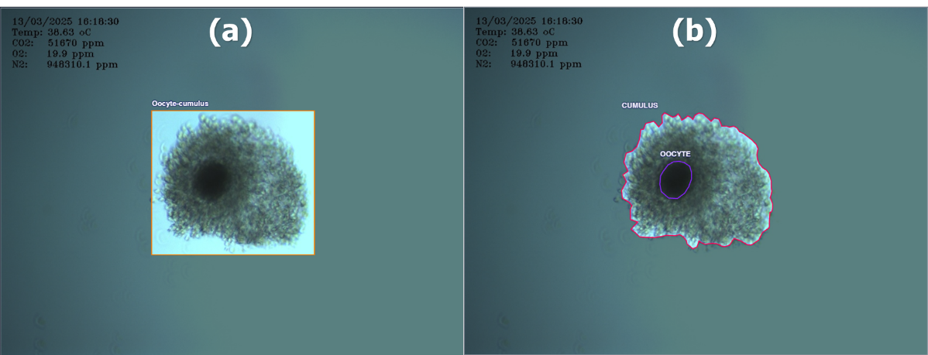

**Fig. 4** Annotation of oocyte and cumulus cells for (a) object detection and (b) segmentation model

|  |  |
| --- | --- |
| $$x\left(θ\right)=x_{c}+r\left(θ\right)\cos{θ}$$ | (6) |
| $$y\left(θ\right)=y_{c}+r\left(θ\right)\sin{θ}$$ | (7) |

At each scanning point along this spiral trajectory, the system captures images and applies a deep learning-based object detection model to identify oocytes positioned near the center of the camera frame. Given a well radius $r_{w}=1.75 mm$ and a camera frame size of $400 μm×300 μm$, an optimal spacing coefficient b = 0.0522 was experimentally determined. This parameter ensures comprehensive well coverage by the camera frame, optimizing both scanning duration and total travel distance. The maximum spiral angle $θ_{max}$ required for complete well coverage can thus be calculated as follows:

|  |  |
| --- | --- |
| $$θ_{max}=\frac{r_{w}}{b}+\frac{π}{5}$$ | (8) |

The integration of precise X–Y stage control, robust circle detection algorithms, and an optimized Archimedean spiral scanning strategy enables the system to detect and track oocytes with high accuracy reliably. This approach ensures stable and accurate cell identification and localization, making the system adaptable to various standard culture dishes commonly used in cell culture applications.

### **Oocyte detection and time-lapse using deep learning**

Accurate localization of oocytes within the culture dish is crucial for reliable time-lapse imaging, as it necessitates precise detection and positioning of the oocyte within the camera frame to obtain accurate spatial coordinates. In this study, the YOLOv8 architecture was employed for object detection and segmentation to achieve this objective. YOLOv8 utilizes a convolutional neural network designed for rapid detection and effective segmentation, making it particularly well-suited for real-time imaging of dynamic biological specimens [43]. Annotated images acquired from the microscope camera for training purposes are shown in **Fig. 4**. A dataset of over 4,900 annotated images was created and divided into training (60%), validation (20%), and testing (20%) subsets. After detection, the microscope stage aligned the bounding box center with the camera frame center, and the oocyte coordinates were recorded for subsequent imaging steps. In the segmentation model (**Fig. 4(b)**), cumulus and oocyte regions were delineated, and their respective areas were quantitatively assessed throughout the time-lapse imaging process. Cumulus cell expansion is a critical parameter in assessing oocyte maturation [44], [45]. Generally, increased cumulus expansion correlates positively with improved oocyte quality and higher fertilization potential [46]. Recent studies have further indicated that abnormalities in cumulus expansion can signify diminished oocyte quality, potentially impairing embryo development and implantation outcomes [47].

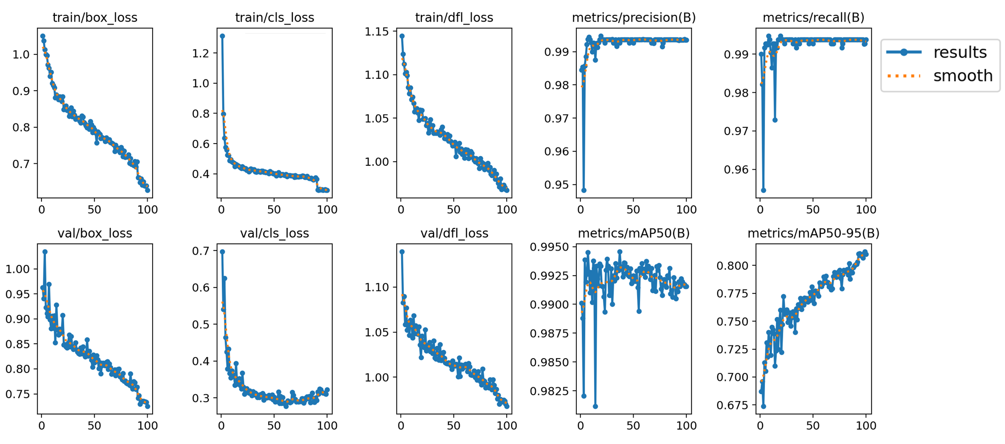

**Fig. 5** Training and validation losses for bounding box regression, classification, and distribution focal loss.

# **results and discussions**

## **Oocyte detection and segmentation performance**

Oocyte images were manually collected and annotated prior to training using the YOLOv8 model. The training process was conducted over 100 epochs, with a batch size of 32 and an input image resolution of 640 × 640 pixels. The total loss function in training process is a key metric for object detection as it consolidates errors from both classification and localization, providing a holistic measure of the model's ability to identify and locate objects accurately. In this study, training results indicated a steady decrease and eventual convergence of all loss functions, demonstrating effective model optimization (**Fig. 5**). Additionally, precision and recall metrics progressively improved and converged, reaching values greater than 0.99. The Precision-Recall curve further confirmed model performance, achieving a mean Average Precision (mAP@0.5) of 0.934 for all classes. Evaluation of the trained model was performed on a test dataset, and the outcomes are presented via a confusion matrix (**Fig. 6(a)**). True Positive (TP), False Positive (FP), True Negative (TN), and False Negative (FN) values derived from this confusion matrix indicated accurate classification. Out of the 960 images within the test set, the model correctly identified 957 images containing oocytes.

The oocytes exhibited considerable diversity in morphology, location, size, and color, with positions varying randomly within culture wells. During spiral scanning or when an oocyte drifted toward the well edge, partial occlusion was observed in the acquired images. Nevertheless, the detection model consistently identified these challenging scenarios effectively (**Fig. 6(b)**). Following autofocus adjustments, the segmentation model clearly delineated oocyte and cumulus regions, facilitating subsequent quanti tative analysis (**Fig. 6(c)**). Performance metrics, including accuracy, precision, recall, and F1-score indicated excellent results exceeding 99%. Furthermore, the spiral search trajectory implemented by the microscope achieved a 100% detection rate during time-lapse imaging. These results demonstrate that the proposed system successfully addresses the challenges associated with using standard manual culture dishes, achieving performance comparable to commercial systems that employ specialized microwell formats.

## **Autofocus performance**

**Fig. 7** depicts the Tenengrad sharpness profile acquired as the objective advances along the Z‑axis in 0.05 µm increments. In the well‑edge focusing (**Fig. 7(a)**) a single peak emerges at z ≈ 19.9 µm with a Tenengrad value of approximately 240, demonstrating sub‑micron depth sensitivity and providing a reliable reference for estimating the well centre before the Archimedean scan. For the COC focusing (**Fig. 7(b)**), the three‑dimensional morphology yields several secondary maxima, yet a dominant peak is retained at z ≈ 20.2 µm with a Tenengrad value near 4000—more than sixteen times higher than the well‑e dge peak—highlighting the superior contrast of biological structures. Adaptive smoothing suppresses minor peaks, allowing the algorithm to select the global maximum consistently. Representative frames illustrate progressive sharpening across successive Z planes.



**Fig. 6** (a) Confusion matrix of the oocyte detection model. (b) Bounding box predictions of the detection model for oocytes located in challenging positions or under suboptimal focus conditions. (c) Segmentation results showing the separation of the oocyte and cumulus cells, enabling quantitative growth analysis during time-lapse imaging after successful localization and refocusing.

The performance of the autofocus module was quantitatively evaluated using three complementary metrics: full width at half maximum (FWHM), signal-to-noise ratio (SNR), and smoothness ratio (Table I). Analysis of 80 Z-stack image sequences revealed an FWHM of five frames at the well edge and eight frames at the COC plane, indicating that the gradient-based algorithm effectively identifies sharply defined focal zones—an essential requirement for consistent localization of geometric landmarks during sequential time-lapse imaging. The SNR improved from 8.7 during well focusing to 16.0 for COC imaging, suggesting that biologically textured regions generate a more distinct and reliable focus peak relative to background variation. This enhancement is particularly beneficial under non-uniform lighting conditions, where stable focus is critical. Furthermore, the smooth ness ratio increased from 0.54 to 1.42, reflecting a more continuous and monotonic focus profile in cellular regions, which reduces the likelihood of erroneous local maxima and improves focus stability. Overall, these metrics confirm that the autofocus system provides high-precision, low-noise, and reliable focusing performance suitable for extended time-lapse imaging of biologically sensitive samples.

1. **evaluation of auto-focusing system**

| Object | Images per stack | FWHM  (frames) | SNR | Smoothness ratio |
| --- | --- | --- | --- | --- |
| Well focusing | 80 | 5 | 8.7 | 0.54 |
| Oocyte focusing | 80 | 8 | 16.0 | 1.42 |

## **Cell monitoring and Time-lapses**

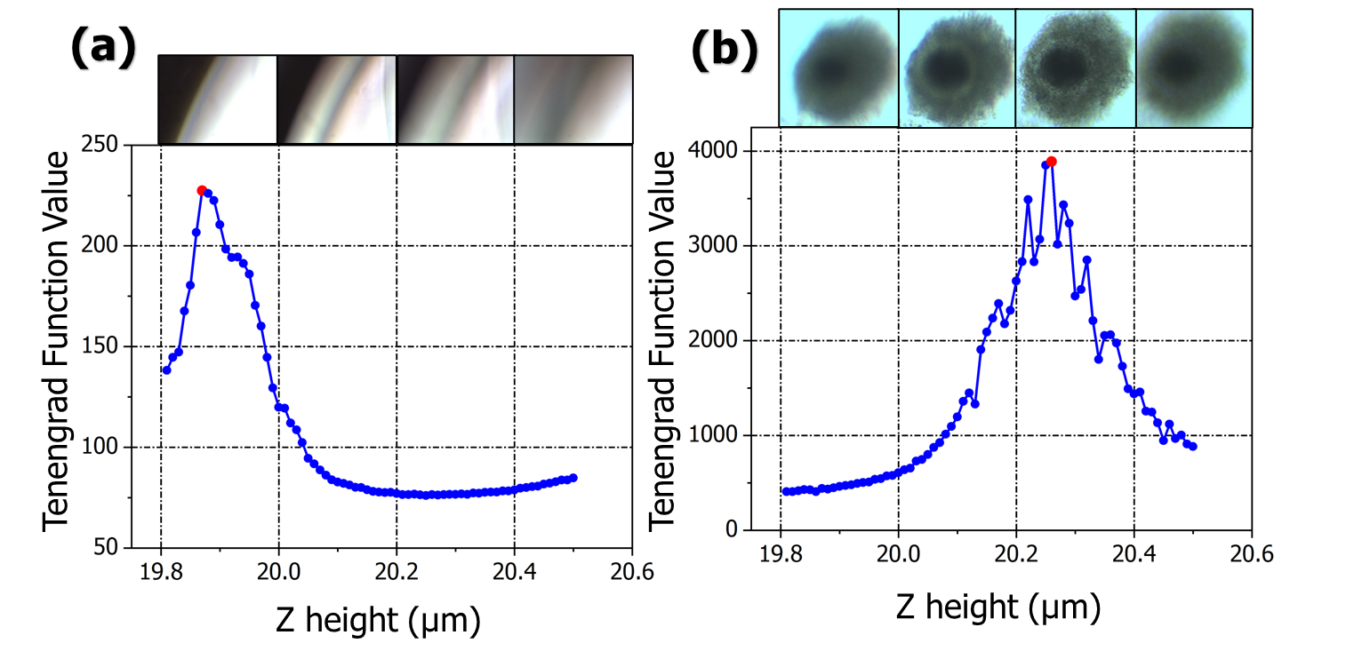

**Fig. 7** Autofocus performance using the Tenengrad gradient function. (a) Focus optimization curve during well edge detection; (b) Sharpness evaluation for oocyte imaging. The peak of the Tenengrad function identifies the optimal Z-position ($z^{*}$) for autofocus, corresponding to the maximum image sharpness.

The performance of the proposed time-lapse microscopy system was assessed by continuously monitoring ten individual COCs over a 30-hour culture period. A deep learning-based segmentation model was employed to quantify morphological changes in both oocyte and cumulus regions (**Fig. 8 (a)**). The results revealed distinct temporal growth patterns, as evidenced by variations in segmented area measurements (**Fig. 8 (b), (c)**). Specifically, the oocyte area exhibited an initial increase during the first 20 hours, followed by a gradual decline. This trend may correspond to cases where cumulus cells failed to expand, remaining compact around the oocyte. In contrast, analysis of the cumulus area (**Fig. 8 (c)**) demonstrated clear and sustained expansion in five samples, while the others showed minimal or no growth. These observations suggest that cumulus expansion serves as a reliable indicator for assessing oocyte maturation. Furthermore, employing deep learning-based segmentation provided robust quantitative metrics for objective morphological assessment, thus validating the efficacy of the developed imaging and analysis approach in automated evaluation of oocyte developmental competence during in vitro maturation .

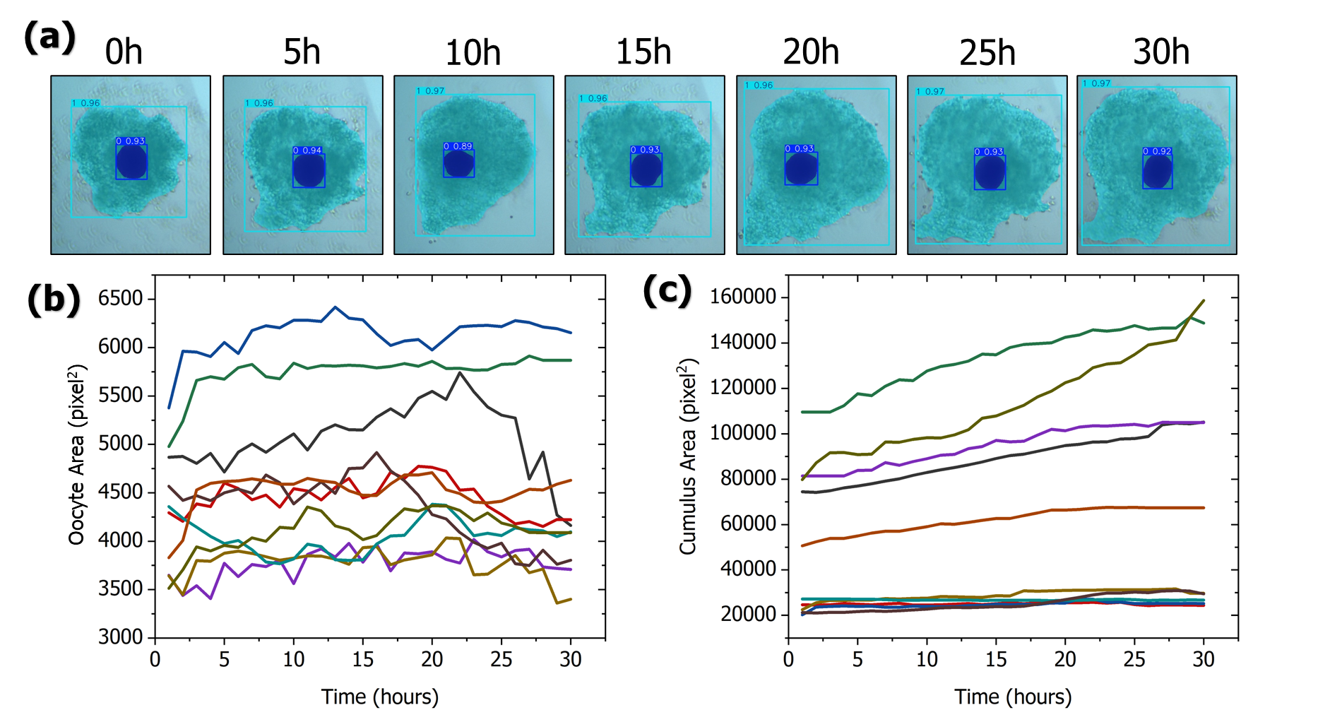

**Fig. 8** Time-lapse segmentation and area quantification of oocyte and cumulus regions. (a) Representative frames showing segmentation results over 30 hours of culture. (b) Temporal changes in oocyte area highlighting samples with minimal morphological change. (c) Temporal expansion of the cumulus area illustrating dynamic growth in developing oocytes during in vitro maturation.

## **Discussion**

Once cumulus cells have fully detached from the oocyte, morphologically competent complexes can be selected for subsequent embryo maturation. At this stage, the specimen’s appearance differs markedly from the original COC; however, the platform’s modular design permits straightforward adaptation to new targets that vary in both size and geometry. By acquiring a modest set of annotated images and retraining the deep-learning detector, the existing time-lapse workflow, including autofocus, spiral scanning, and segmentation, remains unchanged. **Fig. 9** illustrates a representative embryo-maturation sequence captured by the proposed system. Panels A–M document successive cleavage events, enabling continuous assessment of developmental kinetics. Coupled with the quantitative COC expansion curves presented earlier, this visual record facilitates objective ranking and selection of embryos with the highest developmental potential.

Beyond its demonstrated applications in reproductive studies, the system’s modular architecture and software pipeline provide a versatile foundation suitable for various cell types and experimental conditions. Its compatibility with standard culture vessels and implementation of a training-free autofocus method further enhance accessibility, making advanced time-lapse microscopy feasible even for laboratories with limited resources. Future developments may include integrating additional morphological and kinetic parameters, such as cytoplasmic textures, mitotic events, and detailed cell-cell interactions, to enrich analy tical insights and predictive capabilities. Moreover, this study lays the groundwork for applying advanced real-time cell tracking methodologies in broader research domains, including cancer biology, stem cell differentiation studies, and drug response analyses. Overall, the presented self-driving microscopy platform represents a significant step forward in quantitative, non-invasive analysis of complex biological systems, offering valuable tools for diverse research and clinical applications.

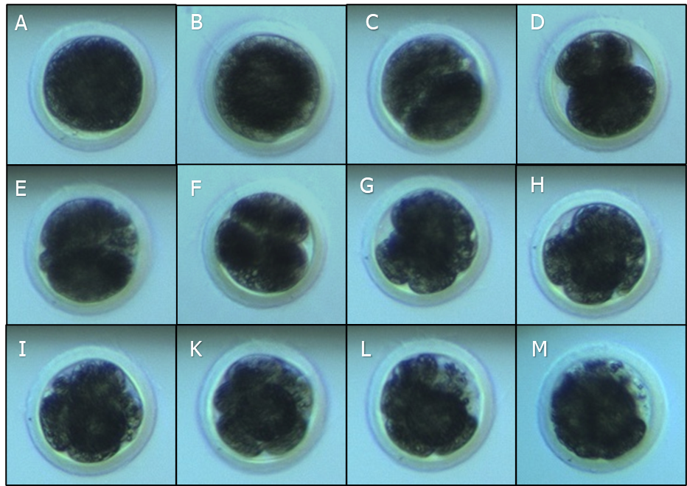

**Fig. 9** Time-lapse sequence of embryo development during in vitro fertilization (IVF) using the proposed automated microscopy system.

# **CONCLUSION**

This study demonstrates the feasibility and effectiveness of an automated time-lapse imaging system for high-resolution monitoring of oocytes and cumulus complexes during in vitro maturation. The integration of deep learning-based detection, segmentation, autofocus, and motion control enables precise tracking of cells that undergo significant morphological changes over time. The system successfully captures dynamic features such as oocyte stability and cumulus expansion, both of which are key indicators of developmental progression. Our results show that the platform delivers high accuracy, adaptability, and robustness under variable culture conditions. In addition to reproductive applications, the methodology and open-source architecture can be extended to monitor other cell types in developmental biology, cancer research, or drug screening. Future work will explore predictive modeling using morphokinetic features and real-time feedback to optimize culture conditions, further enhancing the role of intelligent imaging systems in biological discovery.

**ACKNOWLEDGMENTS**

This work was funded by Vingroup Joint Stock Company and supported by Vingroup Innovation Foundation (VINIF) under project code VINIF.2022.DA00030.

**References**

[1] Q. Yang *et al.*, “Analysis of maturation dynamics and developmental competence of in vitro matured oocytes under time-lapse monitoring,” *Reproductive Biology and Endocrinology*, vol. 19, no. 1, pp. 1–11, Dec. 2021, doi: 10.1186/S12958-021-00868-0/TABLES/4.

[2] C. Giménez, L. Conversa, L. Murria, and M. Meseguer, “Time-lapse imaging: Morphokinetic analysis of in vitro fertilization outcomes,” *Fertil Steril*, vol. 120, no. 2, pp. 218–227, Aug. 2023, doi: 10.1016/J.FERTNSTERT.2023.06.015/ASSET/93AA61EA-11C7-41DE-B0B0-5BD51FC89648/MAIN.ASSETS/FX7.JPG.

[3] K. Kirkegaard, A. Ahlström, H. J. Ingerslev, and T. Hardarson, “Choosing the best embryo by time lapse versus standard morphology,” *Fertil Steril*, vol. 103, no. 2, pp. 323–332, Feb. 2015, doi: 10.1016/j.fertnstert.2014.11.003.

[4] G. C. Sacks *et al.*, “Time-Lapse Incubation for Embryo Culture-Morphokinetics and Environmental Stability May Not Be Enough: Results from a Pilot Randomized Controlled Trial,” *J Clin Med*, vol. 13, no. 6, p. 1701, Mar. 2024, doi: 10.3390/JCM13061701/S1.

[5] M. G. Minasi, P. Greco, M. T. Varricchio, P. Barillari, and E. Greco, “The clinical use of time-lapse in human-assisted reproduction,” *Ther Adv Reprod Health*, vol. 14, Jan. 2020, doi: 10.1177/2633494120976921.

[6] D. Moreau and J. Gruenberg, “Automated microscopy and high content screens (phenotypic screens) in academia labs,” *Chimia (Aarau)*, vol. 70, no. 12, pp. 878–882, 2016, doi: 10.2533/CHIMIA.2016.878,.

[7] A. Gervasi, P. Cardol, and P. E. Meyer, “Automated Open-Hardware Multiwell Imaging Station for Microorganisms Observation,” *Micromachines 2022, Vol. 13, Page 833*, vol. 13, no. 6, p. 833, May 2022, doi: 10.3390/MI13060833.

[8] C. Stewart and J. Giannini, “Inexpensive, open source epifluorescence microscopes,” *J Chem Educ*, vol. 93, no. 7, pp. 1310–1315, Jul. 2016, doi: 10.1021/ACS.JCHEMED.5B00984/ASSET/IMAGES/LARGE/ED-2015-00984T_0005.JPEG.

[9] L. Yang *et al.*, “Machine learning in time-lapse imaging to differentiate embryos from young vs old mice,” *Biol Reprod*, vol. 110, no. 6, pp. 1115–1124, Jun. 2024, doi: 10.1093/BIOLRE/IOAE056.

[10] J. A. Cribb *et al.*, “An Automated High-throughput Array Microscope for Cancer Cell Mechanics,” *Scientific Reports 2016 6:1*, vol. 6, no. 1, pp. 1–10, Jun. 2016, doi: 10.1038/srep27371.

[11] A. F. Laing *et al.*, “An automated microfluidic device for time-lapse imaging of mouse embryonic stem cells,” *Biomicrofluidics*, vol. 13, no. 5, Sep. 2019, doi: 10.1063/1.5124057,.

[12] P. Cicuta *et al.*, “Robotic microscopy for everyone: the OpenFlexure microscope,” *Biomedical Optics Express, Vol. 11, Issue 5, pp. 2447-2460*, vol. 11, no. 5, pp. 2447–2460, May 2020, doi: 10.1364/BOE.385729.

[13] E. E. Thomson *et al.*, “Gigapixel imaging with a novel multi‐camera array microscope,” *Elife*, vol. 11, Dec. 2022, doi: 10.7554/ELIFE.74988.

[14] R. Sciorio, J. K. Thong, and S. J. Pickering, “Comparison of the development of human embryos cultured in either an EmbryoScope or benchtop incubator,” *J Assist Reprod Genet*, vol. 35, no. 3, pp. 515–522, Mar. 2018, doi: 10.1007/S10815-017-1100-6/METRICS.

[15] I. Rubio *et al.*, “Clinical validation of embryo culture and selection by morphokinetic analysis: a randomized, controlled trial of the EmbryoScope,” *Fertil Steril*, vol. 102, no. 5, pp. 1287-1294.e5, Nov. 2014, doi: 10.1016/J.FERTNSTERT.2014.07.738.

[16] P. Allard, F. Papazotos, and L. Potvin-Trottier, “Microfluidics for long-term single-cell time-lapse microscopy: Advances and applications,” *Front Bioeng Biotechnol*, vol. 10, p. 968342, Oct. 2022, doi: 10.3389/FBIOE.2022.968342/XML.

[17] C. M. Svensson, A. Medyukhina, I. Belyaev, N. Al-Zaben, and M. T. Figge, “Untangling cell tracks: Quantifying cell migration by time lapse image data analysis,” *Cytometry Part A*, vol. 93, no. 3, pp. 357–370, Mar. 2018, doi: 10.1002/CYTO.A.23249,.

[18] M. A. Lantzi, E. Papakonstantinou, and D. Vlachakis, “Bioinformatic Analysis of Complex In Vitro Fertilization Data and Predictive Model Design Based on Machine Learning: The Age Paradox in Reproductive Health,” *Biology (Basel)*, vol. 14, no. 5, p. 556, May 2025, doi: 10.3390/BIOLOGY14050556/S1.

[19] A. Chitnis and D. Dalle Nogare, “Time-lapse imaging beyond the diffraction limit,” *Methods*, vol. 150, pp. 32–41, Nov. 2018, doi: 10.1016/J.YMETH.2018.07.004.

[20] M. Yokoo and E. Sato, “Cumulus–Oocyte Complex Interactions During Oocyte Maturation,” *Int Rev Cytol*, vol. 235, pp. 251–291, Jan. 2004, doi: 10.1016/S0074-7696(04)35006-0.

[21] M. Du, X. Fu, Y. Zhou, and S. Zhu, “Effects of Trichostatin A on Cumulus Expansion during Mouse Oocyte Maturation,” *Asian-Australas J Anim Sci*, vol. 26, no. 11, p. 1545, Nov. 2013, doi: 10.5713/AJAS.2013.13128.

[22] E. Babayev *et al.*, “Cumulus expansion is impaired with advanced reproductive age due to loss of matrix integrity and reduced hyaluronan,” *Aging Cell*, vol. 22, no. 11, Nov. 2023, doi: 10.1111/ACEL.14004,.

[23] C. Han *et al.*, “Integration of single oocyte trapping, in vitrofertilization and embryo culture in a microwell-structured microfluidic device,” *Lab Chip*, vol. 10, no. 21, pp. 2848–2854, Nov. 2010, doi: 10.1039/C005296E.

[24] S. Ieda *et al.*, “A microwell culture system that allows group culture and is compatible with human single media,” *J Assist Reprod Genet*, vol. 35, no. 10, p. 1869, Oct. 2018, doi: 10.1007/S10815-018-1252-Z.

[25] A. Fernández-Montoro *et al.*, “Alternative Culture Systems for Bovine Oocyte In Vitro Maturation: Liquid Marbles and Differentially Shaped 96-Well Plates,” *Animals*, vol. 13, no. 10, p. 1635, May 2023, doi: 10.3390/ANI13101635/S1.

[26] M. Lane and D. K. Gardner, “Ammonium induces aberrant blastocyst differentiation, metabolism, pH regulation, gene expression and subsequently alters fetal development in the mouse,” *Biol Reprod*, vol. 69, no. 4, pp. 1109–1117, Oct. 2003, doi: 10.1095/BIOLREPROD.103.018093,.

[27] I. Virant-Klun, T. Tomaževič, E. Vrtačnik-Bokal, A. Vogler, M. Krsnik, and H. Meden-Vrtovec, “Increased ammonium in culture medium reduces the development of human embryos to the blastocyst stage,” *Fertil Steril*, vol. 85, no. 2, pp. 526–528, Feb. 2006, doi: 10.1016/j.fertnstert.2005.10.018.

[28] A. Golchin, R. Asadpour, L. Roshangar, and R. Jafari-Jozani, “The Effect of Ammonium Chloride Concentration in In Vitro Maturation Culture on Ovine Embryo Development,” *J Reprod Infertil*, vol. 17, no. 3, p. 144, 2016, Accessed: Jul. 15, 2025. [Online]. Available: https://pmc.ncbi.nlm.nih.gov/articles/PMC4947201/

[29] P. R. Chen, B. K. Redel, K. C. Kerns, L. D. Spate, and R. S. Prather, “Challenges and Considerations during In Vitro Production of Porcine Embryos,” *Cells 2021, Vol. 10, Page 2770*, vol. 10, no. 10, p. 2770, Oct. 2021, doi: 10.3390/CELLS10102770.

[30] A. Agarwal *et al.*, “Oxidative Stress and Assisted Reproduction: A Comprehensive Review of Its Pathophysiological Role and Strategies for Optimizing Embryo Culture Environment,” *Antioxidants 2022, Vol. 11, Page 477*, vol. 11, no. 3, p. 477, Feb. 2022, doi: 10.3390/ANTIOX11030477.

[31] M. L. Reed, “Culture Systems: Embryo Density,” *Methods in Molecular Biology*, vol. 912, pp. 273–312, 2012, doi: 10.1007/978-1-61779-971-6_16.

[32] D. A. Van Valen *et al.*, “Deep Learning Automates the Quantitative Analysis of Individual Cells in Live-Cell Imaging Experiments,” *PLoS Comput Biol*, vol. 12, no. 11, p. e1005177, Nov. 2016, doi: 10.1371/JOURNAL.PCBI.1005177.

[33] C. Shim, W. Kim, T. T. D. Nguyen, D. Y. Kim, Y. S. Choi, and Y. D. Chung, “CellTrackVis: interactive browser-based visualization for analyzing cell trajectories and lineages,” *BMC Bioinformatics*, vol. 24, no. 1, pp. 1–14, Dec. 2023, doi: 10.1186/S12859-023-05218-Y/FIGURES/9.

[34] C. Shim, W. Kim, T. T. D. Nguyen, D. Y. Kim, Y. S. Choi, and Y. D. Chung, “CellTrackVis: interactive browser-based visualization for analyzing cell trajectories and lineages,” *BMC Bioinformatics*, vol. 24, no. 1, Dec. 2023, doi: 10.1186/S12859-023-05218-Y.

[35] A. Zargari *et al.*, “DeepSea is an efficient deep-learning model for single-cell segmentation and tracking in time-lapse microscopy,” *Cell Reports Methods*, vol. 3, no. 6, p. 100500, Jun. 2023, doi: 10.1016/J.CRMETH.2023.100500.

[36] C. Wen *et al.*, “3deecelltracker, a deep learning-based pipeline for segmenting and tracking cells in 3d time lapse images,” *Elife*, vol. 10, Mar. 2021, doi: 10.7554/ELIFE.59187.

[37] E. N. Ward, A. Scheeder, M. Barysevich, and C. F. Kaminski, “Self-Driving Microscopes: AI Meets Super-Resolution Microscopy,” *Small Methods*, p. 2401757, 2025, doi: 10.1002/SMTD.202401757;PAGE:STRING:ARTICLE/CHAPTER.

[38] Q. Zhang *et al.*, “Adaptive optics for optical microscopy [Invited],” *Biomed Opt Express*, vol. 14, no. 4, p. 1732, Apr. 2023, doi: 10.1364/BOE.479886.

[39] J. Zhang, Y. F. Fu, H. Shen, Q. Liu, L. N. Sun, and L. G. Chen, “Precision autofocus in optical microscopy with liquid lenses controlled by deep reinforcement learning,” *Microsyst Nanoeng*, vol. 10, no. 1, p. 201, Dec. 2024, doi: 10.1038/S41378-024-00845-8.

[40] P. Subudhi, S. Sivapatham, R. Narasimhan A, B. Kumar, and D. Punetha, “Enhancing photovoltaic performance in tin-based perovskite solar cells: A unified approach utilizing numerical simulation and machine learning techniques,” *J Power Sources*, vol. 639, p. 236639, May 2025, doi: 10.1016/J.JPOWSOUR.2025.236639.

[41] S. Kumar, V. Sagar, and D. Punetha, “A comparative study on facial expression recognition using local binary patterns, convolutional neural network and frequency neural network,” *Multimed Tools Appl*, vol. 82, no. 16, pp. 24369–24385, Jul. 2023, doi: 10.1007/S11042-023-14753-Y;PAGE:STRING:ARTICLE/CHAPTER.

[42] K. V, S. S, M. Sendil, K. Nagarajan, and D. Punetha, “Hybrid ensemble - deep transfer model for early cassava leaf disease classification,” *Heliyon*, vol. 10, no. 16, p. e36097, Aug. 2024, doi: 10.1016/J.HELIYON.2024.E36097.

[43] M. Sohan, T. Sai Ram, and Ch. V. Rami Reddy, “A Review on YOLOv8 and Its Advancements,” pp. 529–545, 2024, doi: 10.1007/978-981-99-7962-2_39.

[44] A. Akbari *et al.*, “Differential Gene Expressions of CALM1, PSMD6, and AK124742 Long Noncoding RNA in Cumulus Cells from Polycystic Ovary Syndrome Patients versus Normal Control Women,” *Adv Biomed Res*, vol. 12, no. 1, p. 240, Jan. 2023, doi: 10.4103/ABR.ABR_111_21.

[45] Y. Pan *et al.*, “Estrogen improves the development of yak (Bos grunniens) oocytes by targeting cumulus expansion and levels of oocyte-secreted factors during in vitro maturation,” *PLoS One*, vol. 15, no. 9, p. e0239151, Sep. 2020, doi: 10.1371/JOURNAL.PONE.0239151.

[46] B. Turathum, E. M. Gao, and R. C. Chian, “The Function of Cumulus Cells in Oocyte Growth and Maturation and in Subsequent Ovulation and Fertilization,” *Cells*, vol. 10, no. 9, p. 2292, Sep. 2021, doi: 10.3390/CELLS10092292.

[47] E. Babayev *et al.*, “Cumulus expansion is impaired with advanced reproductive age due to loss of matrix integrity and reduced hyaluronan,” *Aging Cell*, vol. 22, no. 11, p. e14004, Nov. 2023, doi: 10.1111/ACEL.14004.